**Chapter 58 – Our Mission to California, March 2010 to February 2011**

**KEN & FAMILY BIRTHDAY PARTY PRIOR TO LEAVING ON OUR CALIFORNIA MISSION**

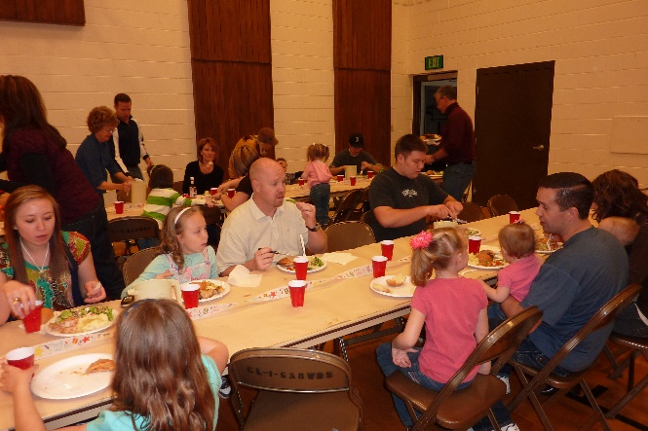DATE: Saturday, February 27th, 2010

TIME: 1 pm to 5 pm

PLACE: Red church on 1300 North (East of our home)

Ken and I went early to decorate and start to get tables and chairs set up, and then others came to help us. It seems like everyone was able to be there except Shellie & her family who live in Arizona.

We had a yummy fried **chicken dinner** with mashed potatoes & gravy, vegetables, rolls, salads & desserts. Ken & I furnished the chicken and paper supplies and everyone else brought the other items. We always enjoy being together. We have a special family.

This was Ken’s birthday so I wanted to have a birthday party for him and since we would be gone for a year and we wouldn’t be able to be to these family members birthdays and give them b-day presents, I decided we should have a birthday party for everyone. I bought **presents** for everyone, and after our lunch, we moved our chairs into a large semi-circle and I proceeded to give out the presents one family at a time. Everyone watched as they opened their presents and then we all watched as the next family opened theirs. They all seemed excited and happy with their gifts, and that made me happy. After everyone had opened their presents, then we had Ken open his gifts and we all sang “Happy Birthday” to him, and cut the birthday cake Bob had gotten for him.

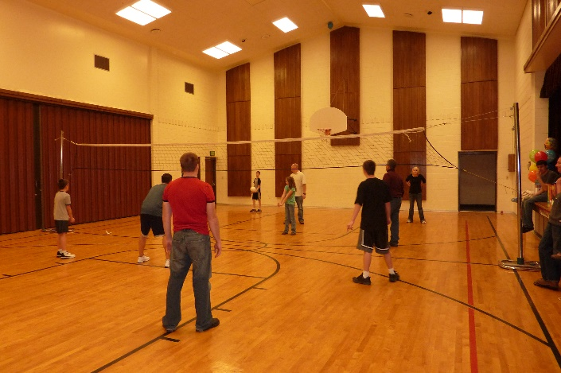 I had asked the moms to bring toys or games for their younger children, so these children had fun playing with each other on the stage, while most of the older children and their parents played **volleyball.** That is a tradition whenever we get together for a barbecue or party, if we hold it in a church or in our backyard. Some of the moms like to play, while others would rather watch the other play or visit. I love to watch these fun games. They are so cute with each other, praising when someone makes a score or hits the ball back into the other court, and if they miss the ball, the others let them know that it was okay and that they all miss at times. They encourage the older children who play also. They laugh and have a great time.

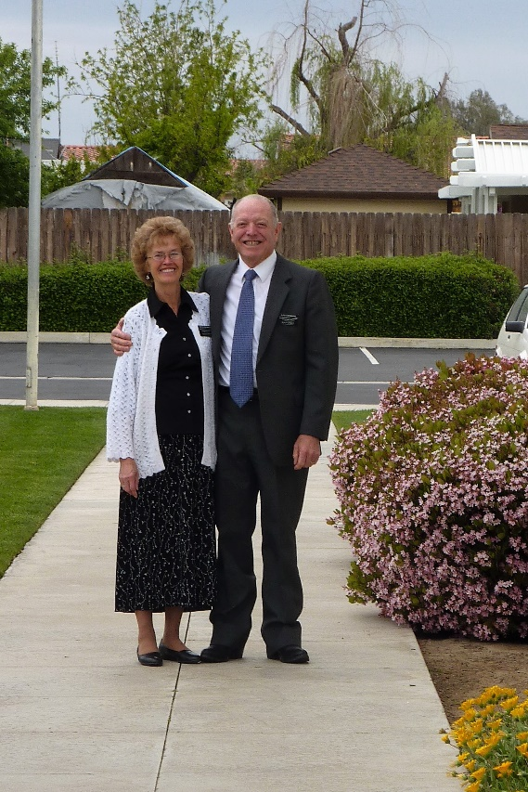**54 - CALIFORNIA MISSION**

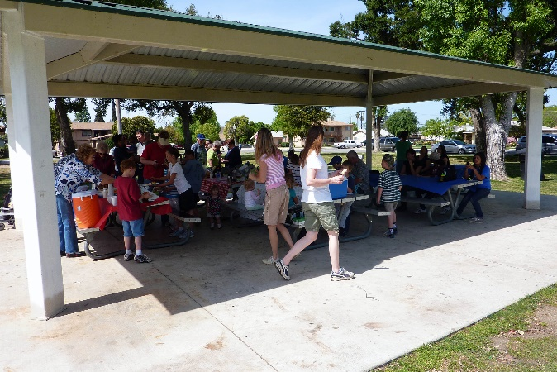The mission department found out from Brother Grenn Clark, that Ken had been a contractor and they needed him on this mission to help another couple missionary built a home for the missionary couple and a duplex for interns and other leadership who would be visiting over extended times. Ken and Elder Judd (and then Elder Shaw) also remodeled other homes on the farm and did repairs on the processing plant and other buildings. They worked 8 hours a day. Brother Lee Brown (who later became our bishop of the Wasco Ward) was the farm manager, who Ken & Elder Judd & Elder Shaw worked under. Since Ken had been a contractor and Elder Judd and Elder Shaw were carpenters, Ken was mainly in charge and did the planning and figuring of materials, etc. Ken amazes me at how he can do anything. I didn’t enjoy going to the plant, where he was building the house and duplex as it frightened me to watch him walk the walls they had put up (with nothing to hang on to). Lee, Elder Judd and others would hand him up the roof joices and he would nail them on. I am so thankful that he didn’t fall. Both Elder Judd and Elder Shaw did fall off the roof. On the day that Elder and Sister Judd were leaving, Ken told Elder Judd to get down off the roof and help his wife pack, but he told Ken he could help for a while longer. Then Ken heard a scream and looked over, and Elder Judd wasn’t on the roof. He got down off the roof as quick as he could and they took Elder Judd to the hospital. He had broke both his arms. After we had finished our mission and were home, we got word from Sister Shaw that Elder Shaw had fallen off another roof and broke his arm. Ken thought a lot of Lee and enjoyed being with him. He also enjoyed working and becoming friends with Elder Judd and Elder Shaw. They accomplished a lot during the year we were there.

We were only with the Judd’s for three months, but enjoyed them. We didn’t do much with them because they had a son and his family in Bakersfield, so they went there most weekends. But we became close with **Ken and Vivian Shaw** and did a lot with them. We had Family Home Evening together and took turns having it at each other’s homes. If it was at our home, we would give the lesson, decide on the activity and provide the refreshments, and they would do the same at their home. Their home was a single wide mobile home. They moved into the home when the two “Kens” finished it.

**Vivian and I would be together quite a bit helping with plant activities** or quilting, shopping, etc. The four of us went on trips together – to the coast and also to San Diego. We spent two full days there. We went to the harbor at San Diego and toured the Midway and other ships, we went to the Mormon Battalion Monument, to the San Diego Temple, To Sea World, to the Old World, etc. We had a wonderful time and the weather was perfect. We also went to the Los Angeles temple together several times and stayed over at the Patron house. It was very inexpensive and was just for those going to the temple. We had to reserve a room there in advance. Vivian, Ken and Ken & I went out to eat often also, especially when we went to the temple. We really enjoyed being with them.

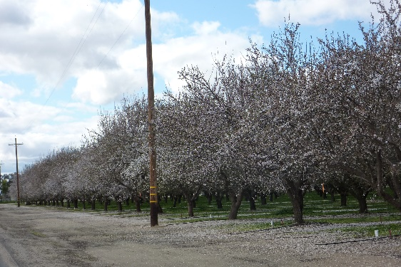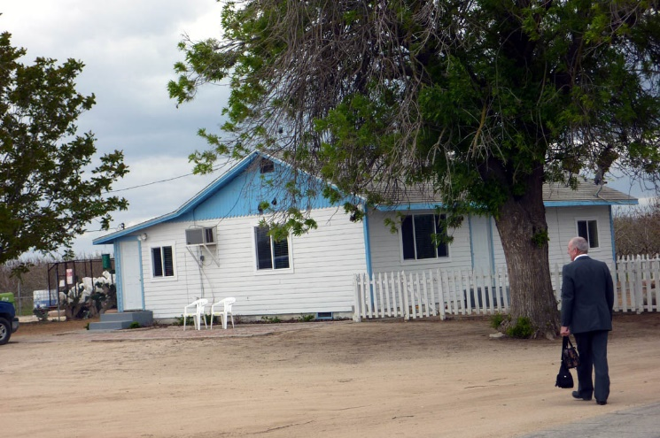We loved our cute little home which was located in the middle of the pistachio groves. It was fun to watch the workers on the equipment pruning the trees and harvesting the nuts in the fall. It was also great to drive through the almond groves, especially in the spring when they were in blossom. It was so beautiful. We lived in Shafter and the plant was in Wasco, so we were in the next town, but Shafter was a farming community (Wasco was also), so it was fun to watch the farmers plowing, disking, planting, and harvesting all kinds of vegetables. I remember seeing the corn fields and the corn was so high, that I started singing: “Oh, what a beautiful morning, Oh, what a beautiful day. The corn is as high as an elephant’s eye and it looks like it’s climbing clear up to the sky.” Ken and I walked over to the one field and saw beautiful flowers on the plants. They were white, pink, purple, etc. They were so pretty and we wondered what kind they were. We later found out that they were the blossoms on the cotton plants. We watched the machine harvest the cotton and that was great to see. One evening, Ken and I were walking through the pistachio groves and were quite a way from home. It was starting to get dark and then we heard howling off in the distance. It was getting closer. Dogs were dropped off at the farm often and they would hook up with the coyotes and form a pack and could be mean. We started for home as fast as we could.

Soon after we arrived at the farm, Lee took us on a tour of the farm and told us that there were 17,000 acres of almonds and 3,000 acres of pistachios. He showed us the equipment they used and explained how they used them and drove us all over the farm pointing out certain things. They later took us on a tour of the plant and that was so interesting also.

We soon made friends at the plant and also at the ward. It wasn’t long until we were given a calling. We were asked to be the nursery leaders. That was quite a challenge, but we loved the children and the two Spanish sisters who were assisting us. They also asked if we would be in the ward choir. Practices were held before our meetings and that worked well. I was given Tara Guyton as my visiting teaching companion and we were giving seven sisters to visit teach. Some were Spanish. I enjoyed getting to know them and enjoyed visiting them. The ward had wonderful ward parties and activities. They decorated so beautifully and the food was always so delicious. Vivian and I were invited to everything. The plant had a large park in the center of the homes for the personal and their families who were in the plant management and staff. We held plant and ward activities there. The main one was the “Farm Fun Day” for all the plant employees, who were mainly Spanish. They had a petting zoo, a bounce house, a clown, a booth where they did face painting, they had a snow cone machine and Ken and I helped there when I wasn’t telling stories over in my booth. They had game booths and served lunch to everyone. That was a fun day. They had a wonderful Christmas party for the plant management, staff and their spouses, and we were also invited. They held it at a beautiful reception center in Bakersfield. The meal was wonderful and they had “minit to winit” games, which we all enjoyed.

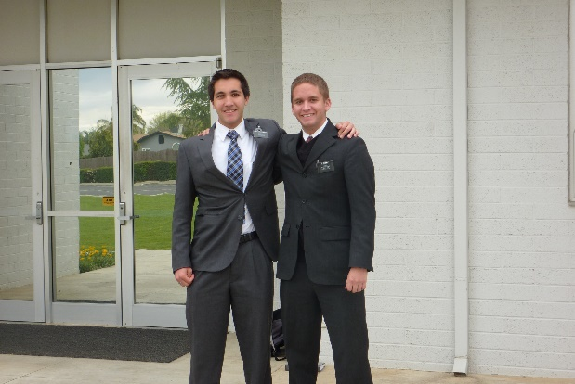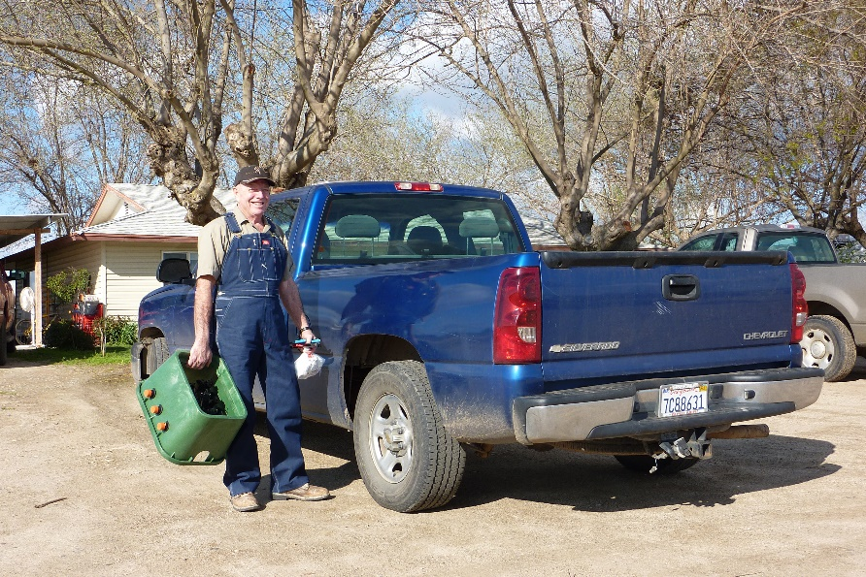Ken got a hernia, caused by lifting a 5-gallon bucket of perfatape mud in a fit of anger as the store clerk wouldn’t go around and use her machine to get the numbers off the bucket, but made him lift it up and put it on the counter. It was so heavy and he was so tired. We were both upset with her because that wasn’t necessary. I was going to write a letter to the manager about her, as it cost us a lot of money and pain for Ken and time away from the mission for him to recover from his operation, but I didn’t write it. Maybe I should have as she needed to be reprimanded. While Ken was recovering, we were able to get permission from our mission president and also from Lee to go back home as our granddaughter, Ashley, was being baptized at that time and we wanted to be there. The doctor thought that would be a good idea, but told him to rest a lot and not lift anything.

**We loved the full-time missionaries** and had them over for dinner at least once or twice a week. The ward members didn’t invite them often as they didn’t have much money, especially the Spanish members. Elder and Sister Shaw invited them often also.

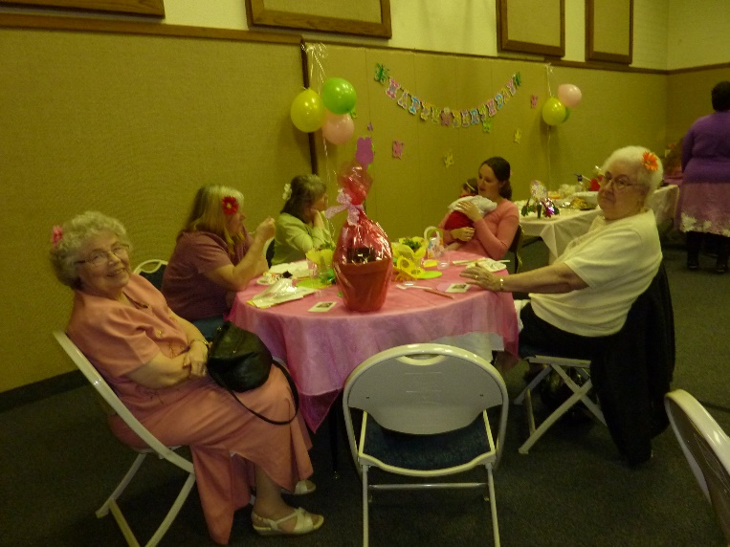Soon after our mission began, Sister Judd asked me if I could take **Sister Louise Hyer**, from our ward, to her doctor in Bakersfield. (Louise is the sister in the pink dress, who is looking at us). She told me that she had been taking Louise to her appointments as Louise is a widow and in her 80’s and can’t drive at the present. I told her I would be happy to, and I loved this sweet little sister, the minute I met her. I was able to take her a few times and always enjoyed being with her. I went to visit her at her lovely home a few times. She had us come for a Valentine’s dinner before we left our mission. She wanted to have a dinner for us before we left. She also invited Lee and Kim Brown and Vivian and Ken Shaw. We had a wonderful time and her dinner was delicious. When I left, I gave her my plant. We called each other a few times after we were home and she told me how the plant just kept blooming. She loved plants and had lots, plus lots of rose bushes and flowers out in her yard. She passed away shortly after we returned home. What a beautiful sister she was.

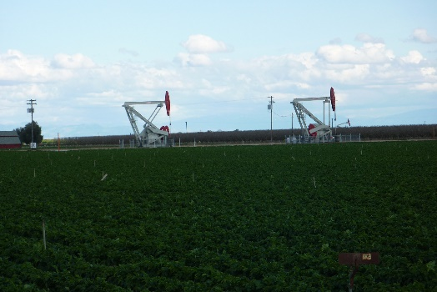As we would drive around the area or go to Roy and Linda’s in Fresno, or to the coast, we would see lots of oil digging’s. The oil companies could come in and put their machines down in the grounds. These machines could move out in all directions for hundreds of feet, and when they found oil, they would purchase a small plot of ground to put their oil digging’s on, from the owner of the land. The owners had to sell them that portion of land and they didn’t get the money for the oil on their property. We didn’t think that was fair.

We mainly shopped in Bakersfield as there wasn’t much in Shafter or Wasco. There was a Winco grocery store as well as a Costco and a health food store, so we had what we needed. Bakersfield is a large city so we were glad we had a GPS to get us where we needed to go. In California, you go from one freeway to another and then exit to what part of the city you want to go to. I was nervous going there by myself the first few times even with the GPS. We found a good family practice doctor there and also a good surgeon when Ken had his hernia operation.

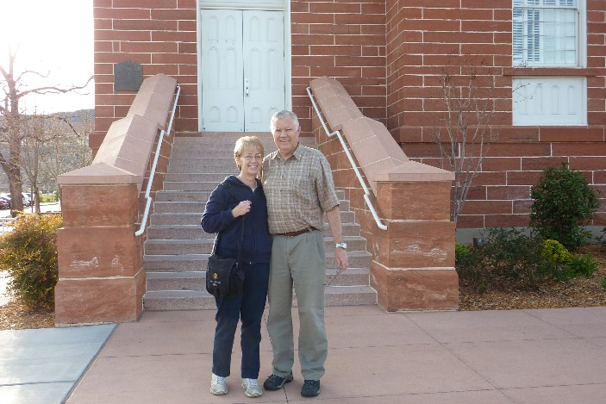We were blessed to have several family members come to visit us on this mission. **Bryce and Deanna** came down when we drove down to Shafter & Wasco, for our mission. We couldn’t bring down everything we needed, but they had offered to drive their car and bring part of the items we needed. They only stayed a day or two and had to get back. We had stopped in St. George, on our way, and visited the historic places there.

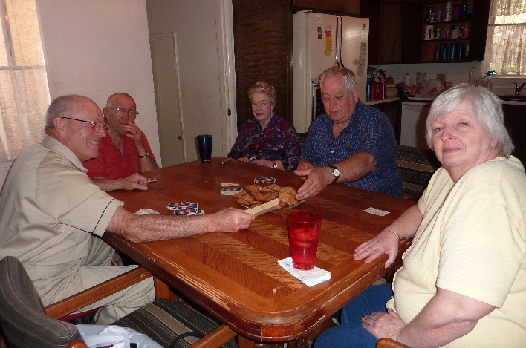**Bob & Carroll** came and stayed for several days. We took them on a tour of the plant and a few other places, but they didn’t feel like traveling again much, but we did take them over to Fresno to visit Roy & Linda. We ate, visited and played games. We didn’t stay the night as they don’t have that much room and we didn’t want to put them out anyway.

With being only an hour away from **Roy & Linda’s** home, we visited them quite frequently on the weekends or they visited us. We also went on several trips together during the holiday breaks. We went to San Francisco and Oakland. We went to Yosemite National Park, and we went to Hollywood and took a bus tour all around. They invited us to spend Christmas Eve and Christmas day with them. That was great. On Christmas Eve, after dinner, we went to the Christmas Street where all the houses on both sides of the street are decorated beautifully. The street has a wide center area and the neighborhood has decorations and lights on that also. On Christmas morning we woke about 7 am, but Roy & Linda were still asleep. We decided to put on our bathing suits and go outside to their hot tub, pick some oranges off their tree and enjoy soaking in the hot tub while eating those sweet, delicious oranges. After Roy & Linda woke, we opened our gifts and then went over to Julianna & Phil’s home where they had invited all of us for Christmas dinner. It was delicious and we had a good visit with them.

**Georgia & Rick** came to visit us and spend a few days. We enjoyed having them and we took them on a tour of the plant and almond & pistachio groves. Another day, we took them down to the ocean. We went on a tour of the Hirst Castle and afterwards, we went to a spot on the beach where the elephant seals were and watched them for a while. We went to another beach and enjoyed walking and talking.

**Shellie** came and dropped off **Jase** for him to spend a week with us while she drove on to Lake Tahoe where she met Sandi and the two of them stayed in a time-share condo Sandi has and they had a wonderful time hiking, shopping, eating, visiting, driving around to see the sights. It was a wonderful sister’s time for them. **Sandi & Shellie** both came to our home afterward and spend a couple of days with us. We took them on a tour of the plant also and one day we all went down to the ocean. It was a cold day, but I had told them that it would be, as it is always cold down by the ocean. I told them to bring heavy jackets, they were surprised as it was hot where we lived, but they were glad they had brought them

**Irven & Sandy and Bryce and Deanna** came down for a few days. We all rode together and went to Sequoia National Park. We were amazed at the size of those trees. We went on a walking trail and really enjoyed our day there. It was beautiful. We enjoyed being together. Bryce & Irven were friends in High School and they stayed friends throughout their lives. Their wives loved each other too. Both couple’s children knew that Ken and I were their aunt and uncle, so they thought each other’s parents were siblings also and that they were all cousins. They were surprised when they learned the truth.

**Scott & Jeff** drove our truck down, so we could load all our belongings in him along with our car. They could only stay overnight as they needed to get back to go to work, but they were able to look around the plant and pick some oranges to take back with them.

We were grateful that so many of our family could come down to visit us. The farm manager was lenient with us and okay with us taking time off to show our family around. Ken is a hard worker and accomplished so much for the plant, that I’m sure they felt he needed some time off to rest and relax with family.

**Ken & Vivian Shaw** were the other couple missionaries for most of the time we were there. We really enjoyed them. Ken Shaw had prostate cancer, but that didn’t slow him down. My Ken would sometimes tell him to take off early and go home and rest, but he wouldn’t quit until Ken did. We went on several trips with them. Their son was stationed with his family in San Diego and he was able to get us discount tickets for the “Midway” ship and other ships and to Sea World. We also went to old town and to the Mormon Battalion monument. We had a great time. We also went to the ocean with them. We went to the Las Angeles Temple several times together and stayed overnight in the patron house. We went out to eat several times with them and we took turns hosting Family Home Evenings. When we left to go home, after our mission was completed, they took us out to eat and presented us with beautiful and thoughtful gifts. They are great friends.

**TALK FOR SACRAMENT MEETING in our new Wasco Ward – MAY 23, 2010 while serving our mission on the South Valley Farms in California**

**“MAKE A DIFFERENCE ON YOUR PIECE OF THE WORLD”**

Brother Allred asked if, before I start my talk, I would tell you a little about us and our lives. I grew up in Sunset, Utah in a wonderful home. My five siblings & I were born to good parents who loved the Lord and their family. Elder Browning was born in Victor, Idaho – just below the Teton Peaks. His family moved to Sunset when he was a junior in High School. We both dated others, so our first date was about 3 years later to our stake Sweetheart Ball. **We both love to dance** and, in those days, we did ballroom dancing and there were ward or stake dances just about every Friday or Saturday night, so those were many of our dates. It was after the Stake Harvest Ball, 8 months later, that he asked me to marry him. Ken had always wanted to go on a mission, but wasn’t able to because he helped finance his older brother’s mission, and when he met with our bishop about him going on a mission, our bishop told him that when you find the right person, then marriage can be the mission. We were married in the Salt Lake temple, and we continued to help finance Roy’s mission after we were married. **I told Ken that someday he and I would go on a mission together**, and when we were set apart for our 1st mission, which was to the Philippines, Ken was told that “**the Lord knew his sacrifice and now it was his turn.”** We had a great experience over there and loved the people and were amazed at how the Lord helped us in so many ways. **Our main mission, which our bishop had told us, is our marriage and raising a family. We have 6 children, our two oldest are daughters and then we had 4 sons. We have 20 grandchildren and 5 great grandchildren.**  Our oldest grandson is on a mission in the state of Washington. I was blessed to be able to stay at home while raising our children, but when our sons started going on mission, I went to work as a secretary for an elementary school. I love secretary work and always wanted to be an Elementary school secretary. I later went to the district and retired as a secretary for Staff Development. **Elder Browning is very talented and has had several occupations. He has been successful as a computer programmer and supervisor of data processing, He has been the manager of two church welfare farms which amounted to 7 years, and he has been a contractor.**

The month before leaving for our mission to the Philippines, **we were in the temple with all of our children and their spouses at our youngest son’s marriage. I think that was the happiest day of my life**. We have had many trials and challenges in our lives, just like you and all of us do. We’ve had health problems, financial problems, worries & trials with our children and it is ongoing. We came back from our 1st mission to find that **two of our sons had lost their testimonies**, so we keep their names in the temple and we continue to love and pray for them and their families. We have faith that if we continue to obey Heavenly Father’s commandments and endure to the end, that one day we will be an eternal family. We have trials and they are supposed to make us stronger and hopefully they have. I do know Elder Browning and I have had a wonderful life and the lord has blessed us in so many ways. **We celebrated our 50th anniversary** on the 19th of June last summer with our special family. When we were set apart for this mission, we were both told that our marriage would become even stronger and better. I thought “Wow! We have a great marriage already”, but I can see that is happening. We love being here with all of you wonderful people and are looking forward to getting to know you even better. We love serving the Lord and his children.

The topic I was given to speak on is **“Make a difference on your piece of the world”.** I thought “which piece of the world have I made a difference on and have I made a difference there?” Elder Browning and I have moved around a lot and so we have friends in Arizona, Idaho and several towns in Utah. One of the things I was told in my **patriarchal blessing** was “to cultivate the spirit of peace, the spirit of joy, the spirit of happiness that I may be happy and have a sacred influence upon the lives of others”. In **D&C 136:28-29,** it says: **“If thou art merry, praise the Lord with singing, with music, with dancing, and with a prayer of praise and thanksgiving.  If thou are sorrowful, call on the Lord thy God with supplication, that your souls may be joyful.”**

I have tried to do as my patriarchal blessing stated and make a conscious effort to be happy, and by so doing, it has made me happy. So, I think that one way to make a difference is to read our patriarchal blessings often and try to fulfill what we are asked to do in them. If some of you older teenagers and adults don’t have your patriarchal blessing, I would encourage you to get it as it is a guide for us as we live our lives in this world.

**The Daffodil Principle:**

Several times my daughter had telephoned to say, "Mother, you must come see the daffodils before they are over."  I wanted to go, but it was a two-hour drive from Laguna to Lake Arrowhead. "I will come next Tuesday," I promised, a little reluctantly, on her third call. Next Tuesday dawned cold and rainy. Still, I had promised and so I drove there.  When I finally walked into Carolyn's house and hugged and greeted my grandchildren, I said, "Forget the daffodils, Carolyn!  The road is invisible in the clouds and fog and there is nothing in the world except you and these children that I want to see badly enough to drive another inch!"

My daughter smiled calmly and said, "We drive in this all the time, Mother. I was hoping you'd take me over to the garage to pick up my car." “How far will we have to drive?” I asked. "Just a few blocks," Carolyn said. "I'll drive. I'm used to this." After several minutes of driving, I had to ask, "Where are we going?  This isn't the way to the garage!" "We're going to my garage by the long way,” Carolyn smiled, “by the way of the daffodils." "Carolyn," I said sternly, "please, turn the car around!" "It's all right, Mother, I promise. You will never forgive yourself if you miss this experience."

  After about twenty minutes, we turned onto a small gravel road and I saw a small church. On the far side of the church, I saw a hand lettered sign that read: **“Daffodil Garden.”**

  We got out of the car and each took a child's hand and I followed Carolyn down the path. Then we turned a corner of the path and I looked up and gasped.  Before me lay the most glorious sight! It looked as though someone had taken a great vat of gold and poured it down over the mountain peak and slopes. The flowers were planted in majestic, swirling patterns; in great ribbons and swaths of deep orange, white, lemon yellow, salmon, pink saffron, and butter yellow.  Each different-colored variety was planted as a group, so that it swirled and flowed like its own river with its own unique hue.  There were five acres of flowers.

  "But who has done this?" I asked Carolyn. "It's just one woman," Carolyn answered. "She lives on the property. That's her home.” Carolyn pointed to a well-kept A-frame house that looked small and modest in the midst of all that glory.  We walked up to the house.  On the patio, we saw a poster:

***Answers to the Questions I Know You Are Asking***1. 50,000 bulbs

2.  One at a time, by one woman.  Two hands, two feet, and very little brain.   
  3. Began in 1958.

**There it was--the Daffodil Principle.**

  For me, that moment was a life-changing experience.  I thought of this woman, whom I had never met, who, more than forty years before, had begun, one bulb at a time, to bring her vision of beauty and joy to an obscure mountain top.  Still, just planting one bulb at a time, year after year, had changed the world.  She had created something of indescribable magnificence, beauty, and inspiration.   
  The principle her daffodil garden taught is one of the greatest principles of celebration. That is, learning to move toward our goals and desires one step at a time; learning to use the accumulation of time. When we multiply tiny pieces of time with small increments of daily effort we too will find we can accomplish magnificent things.  We can change the world. We need to begin today—decide what we want to do and accomplish and then—Just Do It!

It's so pointless to think of the lost hours of yesterday.  The question is: How can I make this a lesson celebration instead of a cause for regret? How can I put to use that which I have learned today?   So, stop waiting until your car or home is paid off, until you get a new car or home, until your kids leave the house, until you go back to school, until you finish school, until you lose 10 lbs., until you gain 10 lbs., until you get married, until you get a divorce, until you have kids, until you retire, until Spring, Summer, Fall, or Winter.   **There is no better time than right now to be happy**.  Happiness is a journey, not a destination.  So, work like you don't need money, love like you've never been hurt, and dance like no one's watching.

Several years ago, I was talking to my **mother-in-law and asked her if she had written her life history.**  She said “no, that she didn’t have anything worthy to write about – that she hadn’t done anything in her life which would interest her family or others.” I told her that I knew that wasn’t true. I started asking her questions about her life and as she answered, I began writing them down. It took several months, but she became more excited as she told me of one experience after another. No, she hadn’t become anyone famous in the eyes of the world, but she had raised a good family, had been a temple worker, had done name extraction, had fulfilled several callings in the church. She had had many trials and I told her that by us writing them down, her posterity could benefit from them and from how she handled them. She had made some mistakes, as we all have, but she did love the Lord and tried to keep his commandments and she endured to the end. We can’t all be Bishops, R.S. Presidents, Stake presidents, general authorities or general auxiliary leaders – and neither do we all want to have those positions, but whatever or wherever the Lord calls us to serve, we need to fulfill it to the best of our ability and that is all the Lord expects. He just expects us to do our best.

**Abraham Lincoln said “I do the very best I know how—the very best I can; and I mean to keep on doing so until the end.  If the end brings me out all right, what is said against me won’t amount to anything.  If the end brings me out wrong, 10,000 angels swearing I was right would make no difference”.**

**President Monson** told about two of his Sunday School Teachers and the difference they made in his life. The one had told her class that at the end of the year they would have **a class party**. They were all looking forward to the party, but a while before one of their classmates’ mother died and the Sunday before the party, the teacher showed them the bottle of money they would use for the party, but then she said: “I was wondering how you felt about taking this bottle of money to Jake’s home and give it to his father to help him take care of his family. He said they all agreed that it was more important to give the money to them, so she had them all walk to Jake’s home and they presented it to his father who had tears in his eyes when he thanked them. He was taught it is better to give than to receive. Another teacher had the class give a **scripture before they entered the room**. If they didn’t have one, he gave them one. He said he was thankful to the teacher for he learned many scriptures and at an early age.

**In Moses 2:24-31 and Abraham 4:24-31**, it **tells of the creation of this earth.** “And on the sixth day, the Gods said “Let us go down and form man in our image, after our likeness…So the Gods went down. In the image of the Gods to form they him, male and female to form they them. Man is the crowning creature to step forth according to the divine will. He is in the image and likeness of the Eternal Elohim and to him is given “dominion” over all things. And, then, finally that his purposes shall roll everlastingly onward, God blesses the male and female whom he has created and commands them: “Be fruitful, and multiply and replenish the earth, and subdue it, and have dominion over the fish of the sea, and over the fowl of the air, and over every living thing that moveth upon the earth.” As the sixth day closes, the Creators, viewing their creative labors with satisfaction, see that all things which they have made are very good. **If we are made in the image of God, and we can become like God, what are we waiting for – let’s do all we can to make a difference on our piece of the world.**

**“We can’t do all things, but we can do some things and what we can do, we ought to do.”**

My favorite scripture is **1st Nephi 3:7** “I will go and do the things which the Lord has commanded for I know that the Lord giveth no commandment unto the children of men, save he shall prepare a way that they shall accomplish it.” If we keep the commandments, and try to follow our Savior’s example by forgetting ourselves and thinking of others and serving them, even if it’s just a smile sometimes, we will find happiness and I feel “we will make a difference in our part of the world.”

I closed with my testimony

**When we left from our mission, we received gifts and hugs from our many ward and plant 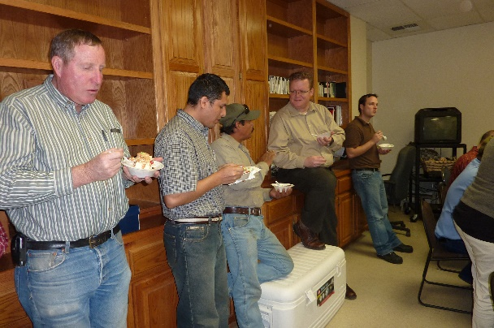friends. The staff at the plant gave Ken & I a going away party**. For gifts, they gave us 50 pounds of almonds, a huge beautiful farm book and a framed picture of the plant which they all signed. Vivian and Ken took us out to eat and gave us gifts. She had put a lot of thought and effort into the gifts. We hated to leave them, but were excited to get back home to our family. We got permission to leave a couple of weeks early from our mission, so we could be to Mike and Becky’s for David’s mission farewell meeting and we were also there when he was set apart by his stake presidency for his mission.

**When we arrived at our home**, Bob told us he didn’t think we wanted to go downstairs to our cute apartment. We found out what he meant. Bob had told us that he didn’t usually go downstairs, but one day he did and to his surprise, there was water all over. We had had problems with the drains and when we heard our sink gurgling, we would have Bob put some draino down his sinks and it would take care of the problem. Well, he didn’t think of that and we were not there to hear the gurgling, so when he or Carroll did laundry, the water came up in our sink, overflowed and went all over. He called the home owner’s insurance and they told him to get carpenters, and people to put down new carpet in the sun room and front room, and linoleum in the kitchen. The insurance would pay for all that, but we would have to pay to have a plumber come to fix the original problem. They had to jack hammer from the sink to the middle of the living room, so fine dust was everywhere. Ken and I paid to have the plumbing all taken care of, and we were able to pick out the carpet and linoleum, from a place in Bakersfield who called their sister company in Riverdale, who we had worked with. We didn’t realize we would walk into such a mess. Carroll had wrapped my souvenirs and nick nacks, statues of Christ, etc., in newspaper and put them in boxes, which I surely appreciated, but there were boxes and stuff all over the cupboards and it was a disaster to walk into. I felt overwhelmed after that long trip home and to find this, but we made our bed, got a good night’s sleep and started cleaning the next day. Scott and Mishelle came over to help us some too. It took several days to get it all clean as that fine dust didn’t just brush or wash off. We had to scrub everything and vacuum everything thoroughly. Mice had gotten into our one big chair which matched our set of couch and love seat, so we had to get rid of it. We decided to go to R.C. Willey’s Furniture Store where we bought a loveseat which reclined and a matching rocking chair which also reclined. In our home in Shafter, there were two big blue recliners, which we loved, so we wanted recliners here, and we have really enjoyed them.

**Here are a couple of my journal entries from our mission**

**Wednesday, September 08, 2010**

I left at 7:30 am, following Ken to the Kimberlina Homes where he is working and where Sister Shaw, myself and other sisters were tying a couple of quilts for Project Linus. **I am thankful for the Holy Ghost who prompts and helps us all the time. Ken went into the back room to carry out the quilting frames and load them into his truck. I gathered up the other things I needed and headed to the car. When I started the car, the thought came to me “Did Ken get all the pieces to the quilting frames?” I drove the car over to his truck as he was just leaving. As I asked him, I looked into the back of his truck and the two pieces of the leg stands were not there. I mentioned it to him and he went in the back door to get them. I went in the kitchen door and was glad I did, as Ken had forgotten to pick up his lunch. I walked on back to the back room to make sure we got all the pieces and parts we needed. I was sure thankful to the Holy Ghost for that thought. He is a precious gift and I hope I can always be worthy to have him with me to help, guide, comfort and prompt me.** Back to the quilts, we are to turn them in Saturday. We had Mishelle Birch come around 9 and stayed all the time. Ilene Payne came for a few minutes and Bonnie Slate came late so was only there for an hour or two. We quit around 1:40 leaving for home, but we had completed the big quilt and enjoyed visiting. These are special, cute sisters here at the South Valley Farms. We were hoping that some other sisters from the ward would come as it was announced the past two Sundays in Church, but none of them came. Anyway, the weather was nice and we enjoyed it. I came home tired, went through the mail, and internet mail and got supper. Ken and I watched Big Valley DVD (one series) before going to bed.

**Friday, September 17, 2010**

Boy, I am worried about Carroll and Linda because of how they are acting and worried about them getting Alzheimer's or Dementia.  When I was talking with Sandi on the phone today, she told me that she was going to the Utah State University football game tomorrow with a friend. My mind didn’t register; I was thinking she was down here for some reason so I asked her if she was going to fly up to the Utah State football game. She said “Mom, it’s only a couple of hours away to Logan.” Finally, it clicked and I realized that yes, she was in Utah. I think I had better worry about myself getting dementia. I was really tired and for some reason I was thinking of her being down here.  I haven't been sleeping well and with Bryce, Deanna, Irven & Sandy here, we have been on the go.  It's been great, but I'm exhausted today.  Mrs. Ochoa kept me really busy at school again today too.  I do really enjoy the children and helping out, however.  Guess I'm just getting old.  I do feel "old" sometimes.  Mom and dad lived to be 83, but Grandpa and Grandma Bushnell both died at 70 and I will be that in December.  I don't plan on dying at 70; however, as with this diet and exercise, I'm pretty healthy. We all got up at 5:30 am this morning, but the pistachio harvesting is on and the big equipment woke us all up around 4:30. I fixed us breakfast and they left at 6 o’clock. I then went for my walk and read my scriptures, then took a shower and got ready to go to Redwood Elementary where I volunteer in Mrs. Ochoa’s third grade class each Friday. Ken made the bed for me again this morning. He’s sure a wonderful guy and I’m sure glad he’s mine.